# Abstract Factory

## Intent

**Abstract Factory** is a creational design pattern that lets you produce families of related objects without specifying their concrete classes.

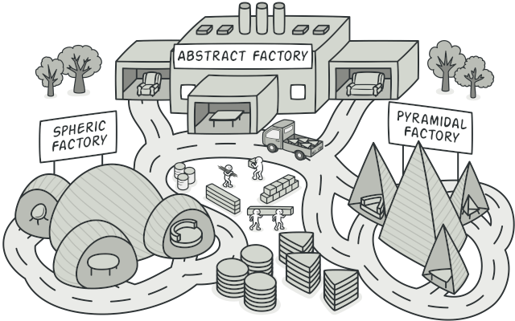

## Structure

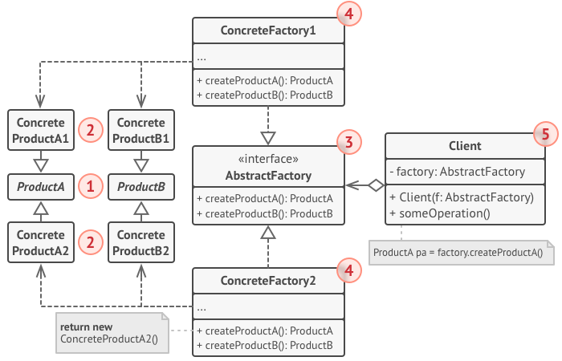

1. **Abstract Products** declare interfaces for a set of distinct but related products which make up a product family.
2. **Concrete Products** are various implementations of abstract products, grouped by variants. Each abstract product (chair/sofa) must be implemented in all given variants (Victorian/Modern).
3. The **Abstract Factory** interface declares a set of methods for creating each of the abstract products.
4. **Concrete Factories** implement creation methods of the abstract factory. Each concrete factory corresponds to a specific variant of products and creates only those product variants.
5. Although concrete factories instantiate concrete products, signatures of their creation methods must return corresponding *abstract* products. This way the client code that uses a factory doesn’t get coupled to the specific variant of the product it gets from a factory. The **Client** can work with any concrete factory/product variant, as long as it communicates with their objects via abstract interfaces.

## Pseudocode

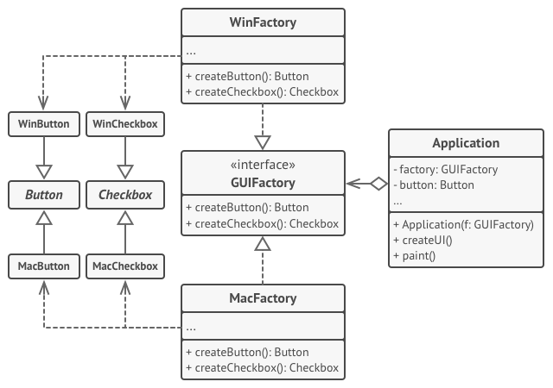

# Factory Method

## Intent

**Factory Method** is a creational design pattern that provides an interface for creating objects in a superclass, but allows subclasses to alter the type of objects that will be created.

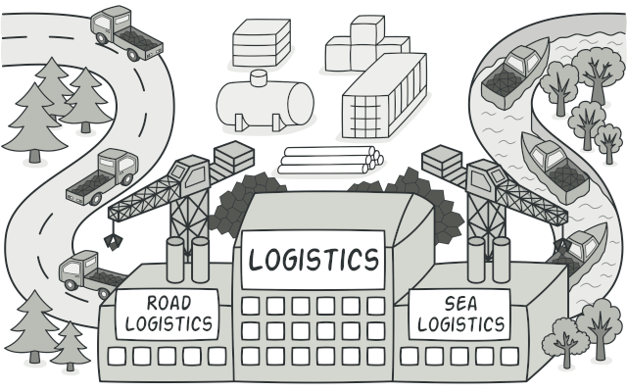

## Structure

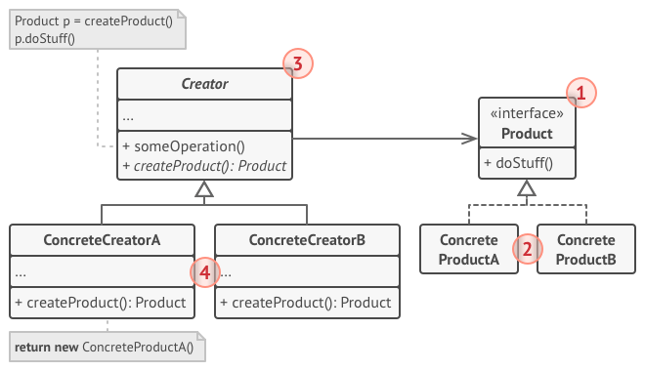

1. The **Product** declares the interface, which is common to all objects that can be produced by the creator and its subclasses.
2. **Concrete Products** are different implementations of the product interface.
3. The **Creator** class declares the factory method that returns new product objects. It’s important that the return type of this method matches the product interface.

You can declare the factory method as abstract to force all subclasses to implement their own versions of the method. As an alternative, the base factory method can return some default product type.

Note, despite its name, product creation is **not** the primary responsibility of the creator. Usually, the creator class already has some core business logic related to products. The factory method helps to decouple this logic from the concrete product classes. Here is an analogy: a large software development company can have a training department for programmers. However, the primary function of the company as a whole is still writing code, not producing programmers.

1. **Concrete Creators** override the base factory method so it returns a different type of product.

Note that the factory method doesn’t have to **create** new instances all the time. It can also return existing objects from a cache, an object pool, or another source.

## Pseudocode

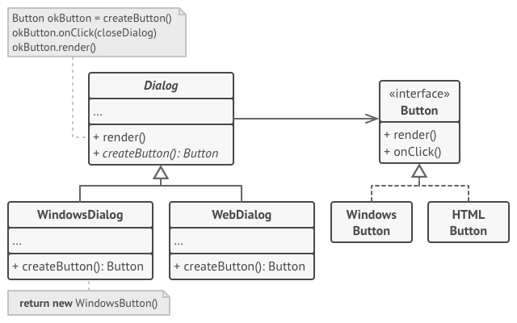

# Prototype

## Intent

**Prototype** is a creational design pattern that lets you copy existing objects without making your code dependent on their classes.

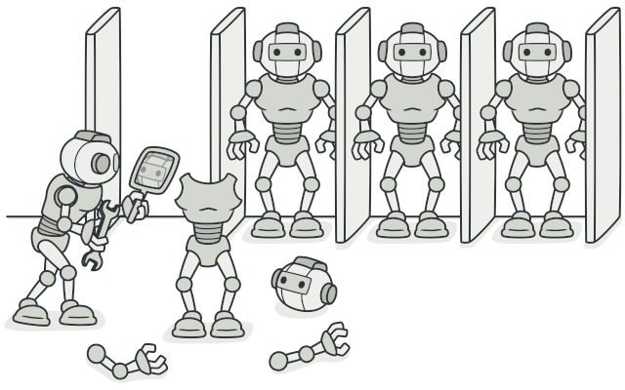

## Real-world analogy

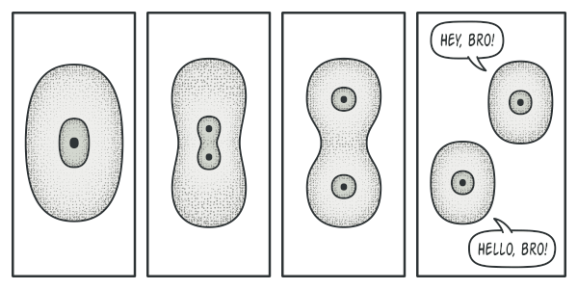

Since industrial prototypes don’t really copy themselves, a much closer analogy to the pattern is the process of mitotic cell division (biology, remember?). After mitotic division, a pair of identical cells is formed. The original cell acts as a prototype and takes an active role in creating the copy.

## Structure

### Basic implementation

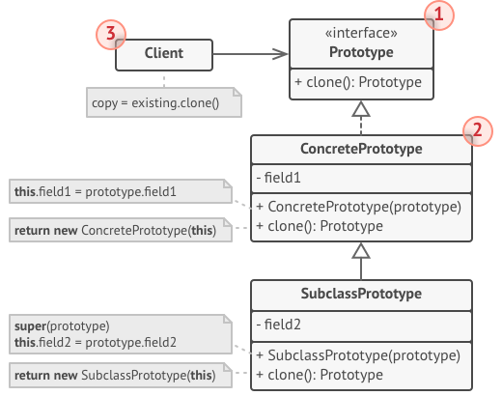

1. The **Prototype** interface declares the cloning methods. In most cases, it’s a single clone method.
2. The **Concrete Prototype** class implements the cloning method. In addition to copying the original object’s data to the clone, this method may also handle some edge cases of the cloning process related to cloning linked objects, untangling recursive dependencies, etc.
3. The **Client** can produce a copy of any object that follows the prototype interface.

### Prototype registry implementation

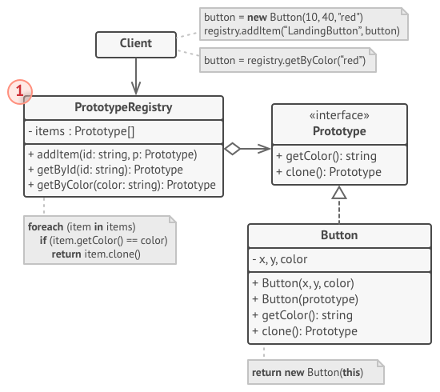

1. The **Prototype Registry** provides an easy way to access frequently-used prototypes. It stores a set of pre-built objects that are ready to be copied. The simplest prototype registry is a name → prototype hash map. However, if you need better search criteria than a simple name, you can build a much more robust version of the registry.

## Pseudocode

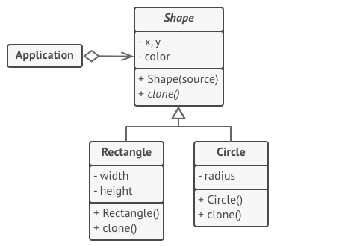

# Singleton

## Intent

**Singleton** is a creational design pattern that lets you ensure that a class has only one instance, while providing a global access point to this instance.

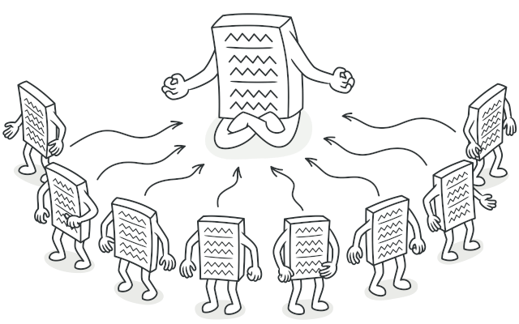

## Real-world analogy

The government is an excellent example of the Singleton pattern. A country can have only one official government. Regardless of the personal identities of the individuals who form governments, the title, “The Government of X”, is a global point of access that identifies the group of people in charge.

## Structure

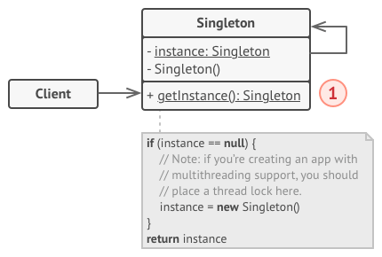

1. The **Singleton** class declares the static method getInstance that returns the same instance of its own class.

The Singleton’s constructor should be hidden from the client code. Calling the getInstance method should be the only way of getting the Singleton object.

# Adapter

## Intent

**Adapter** is a structural design pattern that allows objects with incompatible interfaces to collaborate.

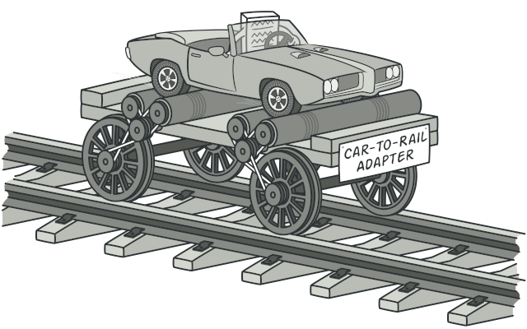

## Real-world analogy



When you travel from the US to Europe for the first time, you may get a surprise when trying to charge your laptop. The power plug and sockets standards are different in different countries. That’s why your US plug won’t fit a German socket. The problem can be solved by using a power plug adapter that has the American-style socket and the European-style plug.

## Structure

### Object adapter

This implementation uses the object composition principle: the adapter implements the interface of one object and wraps the other one. It can be implemented in all popular programming languages.

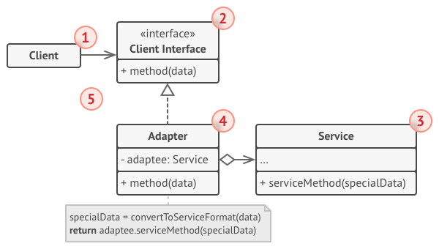

1. The **Client** is a class that contains the existing business logic of the program.
2. The **Client Interface** describes a protocol that other classes must follow to be able to collaborate with the client code.
3. The **Service** is some useful class (usually 3rd-party or legacy). The client can’t use this class directly because it has an incompatible interface.
4. The **Adapter** is a class that’s able to work with both the client and the service: it implements the client interface, while wrapping the service object. The adapter receives calls from the client via the adapter interface and translates them into calls to the wrapped service object in a format it can understand.
5. The client code doesn’t get coupled to the concrete adapter class as long as it works with the adapter via the client interface. Thanks to this, you can introduce new types of adapters into the program without breaking the existing client code. This can be useful when the interface of the service class gets changed or replaced: you can just create a new adapter class without changing the client code.

### Class adapter

This implementation uses inheritance: the adapter inherits interfaces from both objects at the same time. Note that this approach can only be implemented in programming languages that support multiple inheritance, such as C++.

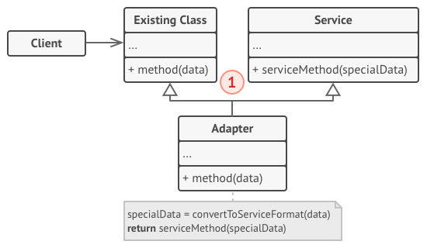

1. The **Class Adapter** doesn’t need to wrap any objects because it inherits behaviors from both the client and the service. The adaptation happens within the overridden methods. The resulting adapter can be used in place of an existing client class.

## Pseudocode

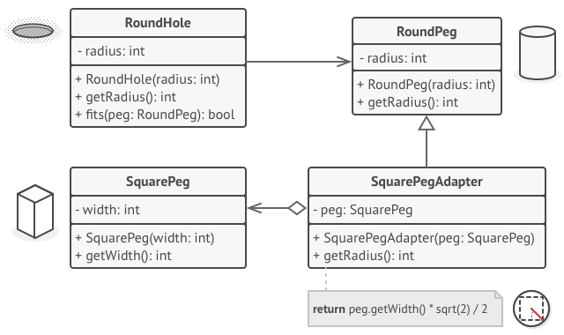

# Bridge

## Intent

**Bridge** is a structural design pattern that lets you split a large class or a set of closely related classes into two separate hierarchies—abstraction and implementation—which can be developed independently of each other.

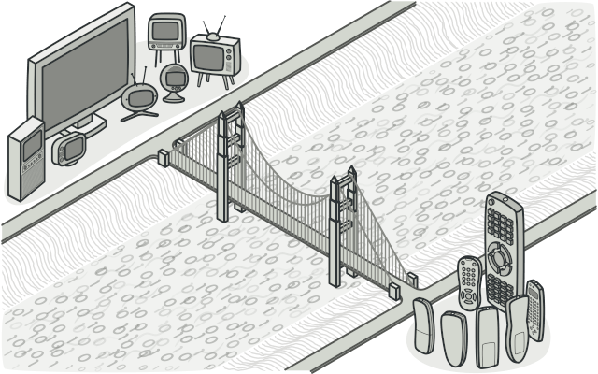

## Structure

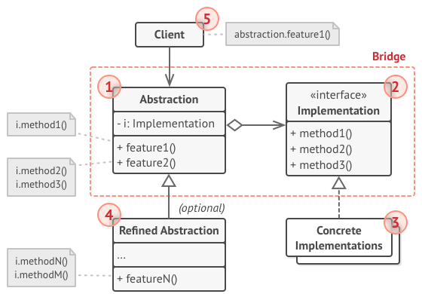

1. The **Abstraction** provides high-level control logic. It relies on the implementation object to do the actual low-level work.
2. The **Implementation** declares the interface that’s common for all concrete implementations. An abstraction can only communicate with an implementation object via methods that are declared here.

The abstraction may list the same methods as the implementation, but usually the abstraction declares some complex behaviors that rely on a wide variety of primitive operations declared by the implementation.

1. **Concrete Implementations** contain platform-specific code.
2. **Refined Abstractions** provide variants of control logic. Like their parent, they work with different implementations via the general implementation interface.
3. Usually, the **Client** is only interested in working with the abstraction. However, it’s the client’s job to link the abstraction object with one of the implementation objects.

## Pseudocode

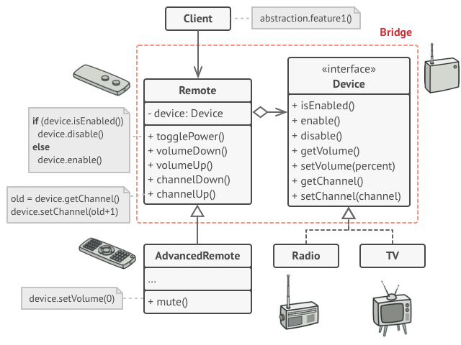

# Composite

## Intent

**Composite** is a structural design pattern that lets you compose objects into tree structures and then work with these structures as if they were individual objects.



## Real-world analogy

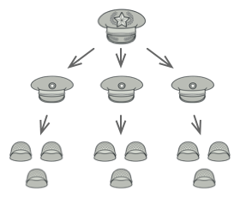

Armies of most countries are structured as hierarchies. An army consists of several divisions; a division is a set of brigades, and a brigade consists of platoons, which can be broken down into squads. Finally, a squad is a small group of real soldiers. Orders are given at the top of the hierarchy and passed down onto each level until every soldier knows what needs to be done.

## Structure

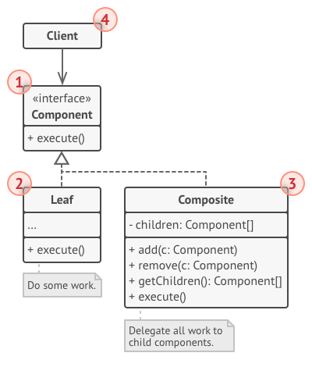

1. The **Component** interface describes operations that are common to both simple and complex elements of the tree.
2. The **Leaf** is a basic element of a tree that doesn’t have sub-elements.

Usually, leaf components end up doing most of the real work, since they don’t have anyone to delegate the work to.

1. The **Container** (aka *composite*) is an element that has sub-elements: leaves or other containers. A container doesn’t know the concrete classes of its children. It works with all sub-elements only via the component interface.

Upon receiving a request, a container delegates the work to its sub-elements, processes intermediate results and then returns the final result to the client.

1. The **Client** works with all elements through the component interface. As a result, the client can work in the same way with both simple or complex elements of the tree.

## Pseudocode

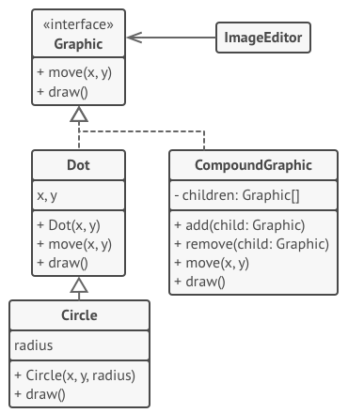

# Decorator

## Intent

**Decorator** is a structural design pattern that lets you attach new behaviors to objects by placing these objects inside special wrapper objects that contain the behaviors.

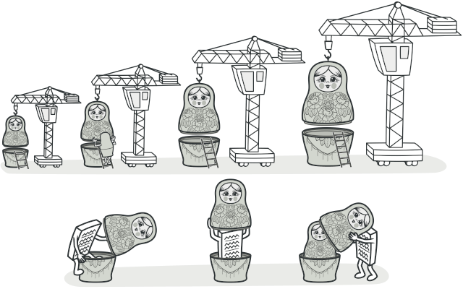

## Real-world analogy



Wearing clothes is an example of using decorators. When you’re cold, you wrap yourself in a sweater. If you’re still cold with a sweater, you can wear a jacket on top. If it’s raining, you can put on a raincoat. All of these garments “extend” your basic behavior but aren’t part of you, and you can easily take off any piece of clothing whenever you don’t need it.

## Structure

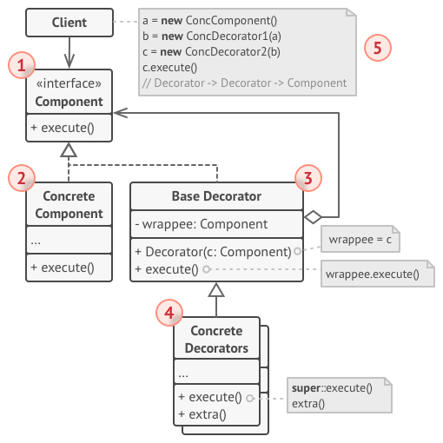

1. The **Component** declares the common interface for both wrappers and wrapped objects.
2. **Concrete Component** is a class of objects being wrapped. It defines the basic behavior, which can be altered by decorators.
3. The **Base Decorator** class has a field for referencing a wrapped object. The field’s type should be declared as the component interface so it can contain both concrete components and decorators. The base decorator delegates all operations to the wrapped object.
4. **Concrete Decorators** define extra behaviors that can be added to components dynamically. Concrete decorators override methods of the base decorator and execute their behavior either before or after calling the parent method.
5. The **Client** can wrap components in multiple layers of decorators, as long as it works with all objects via the component interface.

## Pseudocode

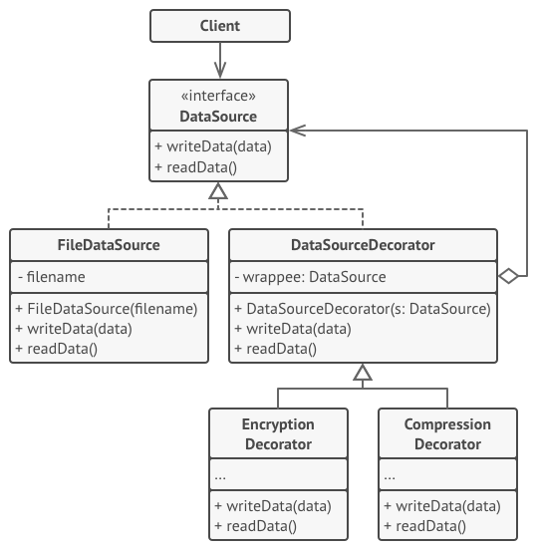

# Facade

## Intent

**Facade** is a structural design pattern that provides a simplified interface to a library, a framework, or any other complex set of classes.

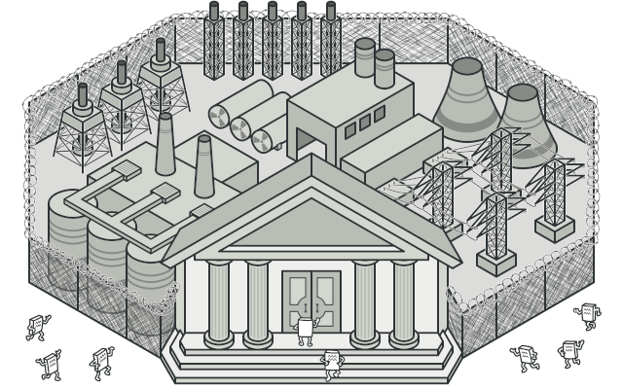

## Real-world analogy

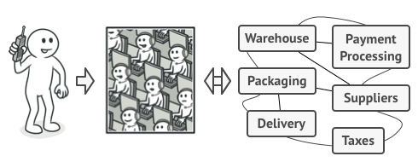

When you call a shop to place a phone order, an operator is your facade to all services and departments of the shop. The operator provides you with a simple voice interface to the ordering system, payment gateways, and various delivery services.

## Structure

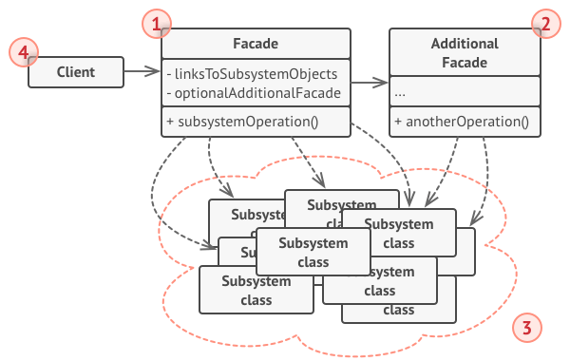

1. The **Facade** provides convenient access to a particular part of the subsystem’s functionality. It knows where to direct the client’s request and how to operate all the moving parts.
2. An **Additional Facade** class can be created to prevent polluting a single facade with unrelated features that might make it yet another complex structure. Additional facades can be used by both clients and other facades.
3. The **Complex Subsystem** consists of dozens of various objects. To make them all do something meaningful, you have to dive deep into the subsystem’s implementation details, such as initializing objects in the correct order and supplying them with data in the proper format.

Subsystem classes aren’t aware of the facade’s existence. They operate within the system and work with each other directly.

1. The **Client** uses the facade instead of calling the subsystem objects directly.

## Pseudocode

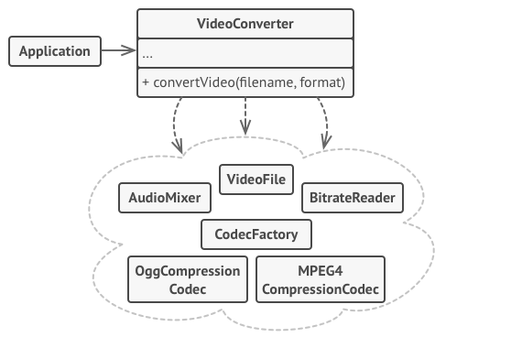

# Proxy

## Intent

**Proxy** is a structural design pattern that lets you provide a substitute or placeholder for another object. A proxy controls access to the original object, allowing you to perform something either before or after the request gets through to the original object.

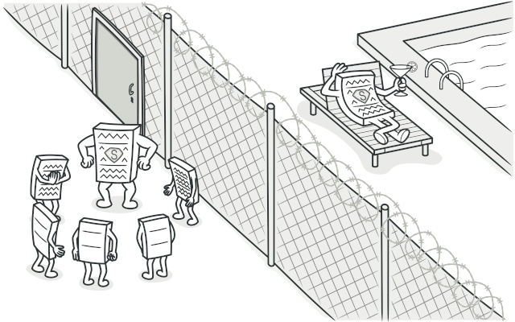

## Real-world analogy

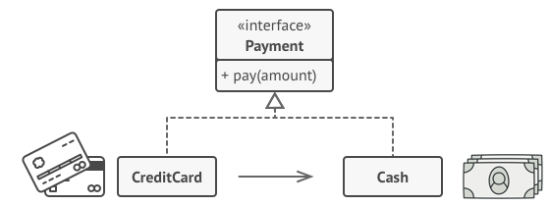

A credit card is a proxy for a bank account, which is a proxy for a bundle of cash. Both implement the same interface: they can be used for making a payment. A consumer feels great because there’s no need to carry loads of cash around. A shop owner is also happy since the income from a transaction gets added electronically to the shop’s bank account without the risk of losing the deposit or getting robbed on the way to the bank.

## Structure

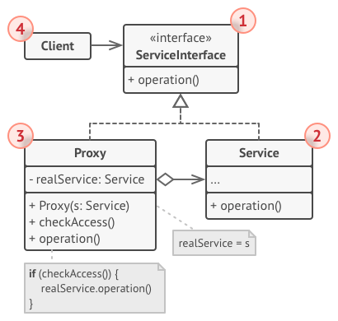

1. The **Service Interface** declares the interface of the Service. The proxy must follow this interface to be able to disguise itself as a service object.
2. The **Service** is a class that provides some useful business logic.
3. The **Proxy** class has a reference field that points to a service object. After the proxy finishes its processing (e.g., lazy initialization, logging, access control, caching, etc.), it passes the request to the service object.

Usually, proxies manage the full lifecycle of their service objects.

1. The **Client** should work with both services and proxies via the same interface. This way you can pass a proxy into any code that expects a service object.

## Pseudocode

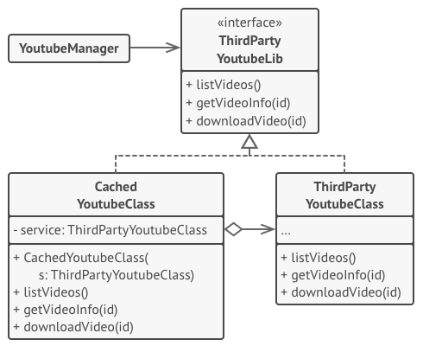

# Command

## Intent

**Command** is a behavioral design pattern that turns a request into a stand-alone object that contains all information about the request. This transformation lets you parameterize methods with different requests, delay or queue a request’s execution, and support undoable operations.

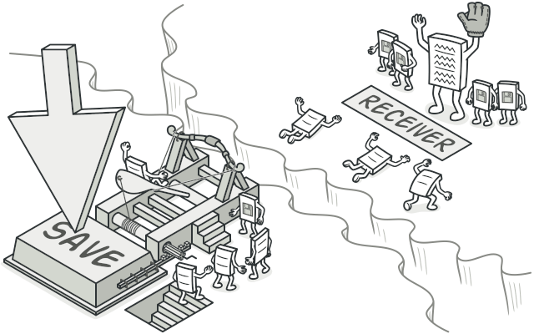

## Real-world analogy

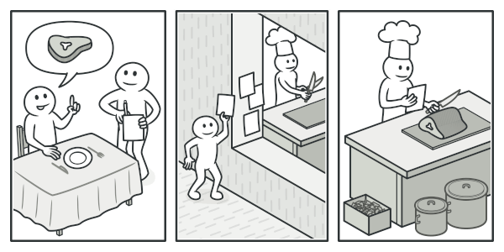

After a long walk through the city, you get to a nice restaurant and sit at the table by the window. A friendly waiter approaches you and quickly takes your order, writing it down on a piece of paper. The waiter goes to the kitchen and sticks the order on the wall. After a while, the order gets to the chef, who reads it and cooks the meal accordingly. The cook places the meal on a tray along with the order. The waiter discovers the tray, checks the order to make sure everything is as you wanted it, and brings everything to your table.

The paper order serves as a command. It remains in a queue until the chef is ready to serve it. The order contains all the relevant information required to cook the meal. It allows the chef to start cooking right away instead of running around clarifying the order details from you directly.

## Structure

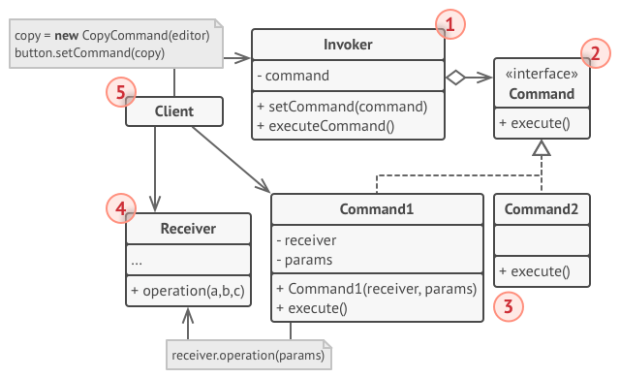

1. The **Sender** class (aka *invoker*) is responsible for initiating requests. This class must have a field for storing a reference to a command object. The sender triggers that command instead of sending the request directly to the receiver. Note that the sender isn’t responsible for creating the command object. Usually, it gets a pre-created command from the client via the constructor.
2. The **Command** interface usually declares just a single method for executing the command.
3. **Concrete Commands** implement various kinds of requests. A concrete command isn’t supposed to perform the work on its own, but rather to pass the call to one of the business logic objects. However, for the sake of simplifying the code, these classes can be merged.

Parameters required to execute a method on a receiving object can be declared as fields in the concrete command. You can make command objects immutable by only allowing the initialization of these fields via the constructor.

1. The **Receiver** class contains some business logic. Almost any object may act as a receiver. Most commands only handle the details of how a request is passed to the receiver, while the receiver itself does the actual work.
2. The **Client** creates and configures concrete command objects. The client must pass all of the request parameters, including a receiver instance, into the command’s constructor. After that, the resulting command may be associated with one or multiple senders.

## Pseudocode

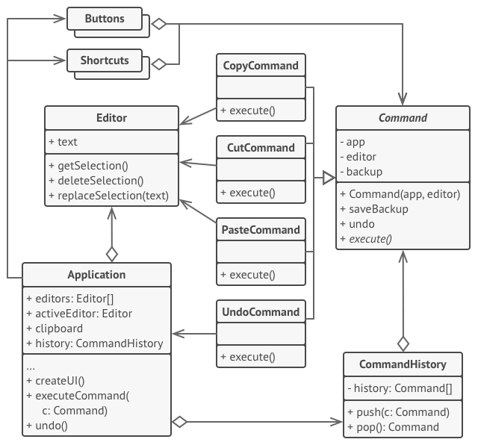

# Iterator

## Intent

**Iterator** is a behavioral design pattern that lets you traverse elements of a collection without exposing its underlying representation (list, stack, tree, etc.).

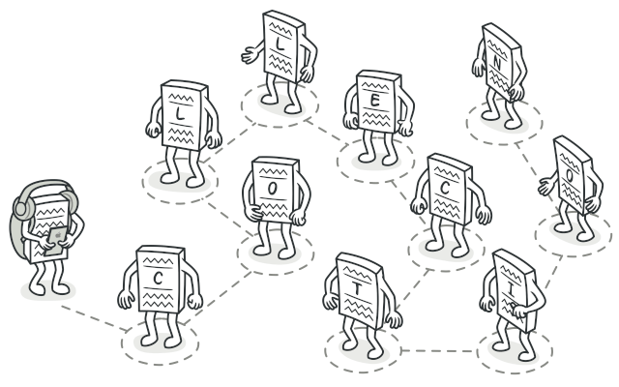

## Real-world analogy

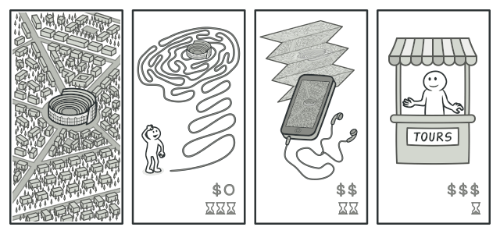

You plan to visit Rome for a few days and visit all of its main sights and attractions. But once there, you could waste a lot of time walking in circles, unable to find even the Colosseum.

On the other hand, you could buy a virtual guide app for your smartphone and use it for navigation. It’s smart and inexpensive, and you could be staying at some interesting places for as long as you want.

A third alternative is that you could spend some of the trip’s budget and hire a local guide who knows the city like the back of his hand. The guide would be able to tailor the tour to your likings, show you every attraction and tell a lot of exciting stories. That’ll be even more fun; but, alas, more expensive, too.

All of these options—the random directions born in your head, the smartphone navigator or the human guide—act as iterators over the vast collection of sights and attractions located in Rome.

## Structure

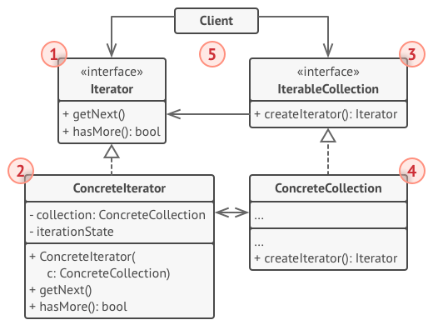

1. The **Iterator** interface declares the operations required for traversing a collection: fetching the next element, retrieving the current position, restarting iteration, etc.
2. **Concrete Iterators** implement specific algorithms for traversing a collection. The iterator object should track the traversal progress on its own. This allows several iterators to traverse the same collection independently of each other.
3. The **Collection** interface declares one or multiple methods for getting iterators compatible with the collection. Note that the return type of the methods must be declared as the iterator interface so that the concrete collections can return various kinds of iterators.
4. **Concrete Collections** return new instances of a particular concrete iterator class each time the client requests one. You might be wondering, where’s the rest of the collection’s code? Don’t worry, it should be in the same class. It’s just that these details aren’t crucial to the actual pattern, so we’re omitting them.
5. The **Client** works with both collections and iterators via their interfaces. This way the client isn’t coupled to concrete classes, allowing you to use various collections and iterators with the same client code.

Typically, clients don’t create iterators on their own, but instead get them from collections. Yet, in certain cases, the client can create one directly; for example, when the client defines its own special iterator.

## Pseudocode

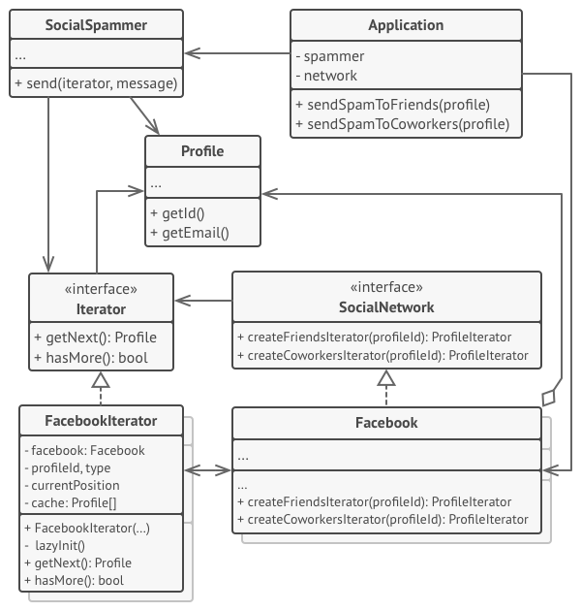

# Observer

## Intent

**Observer** is a behavioral design pattern that lets you define a subscription mechanism to notify multiple objects about any events that happen to the object they’re observing.

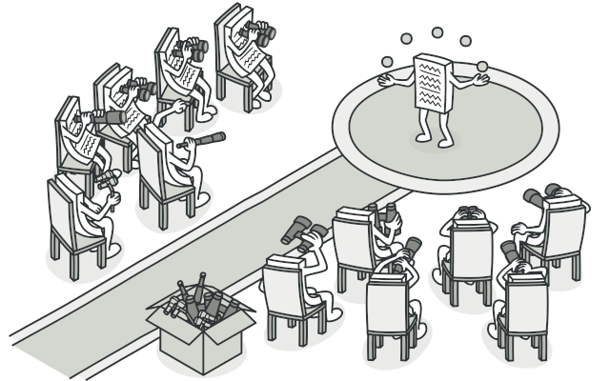

## Real-world analogy



If you subscribe to a newspaper or magazine, you no longer need to go to the store to check if the next issue is available. Instead, the publisher sends new issues directly to your mailbox right after publication or even in advance.

The publisher maintains a list of subscribers and knows which magazines they’re interested in. Subscribers can leave the list at any time when they wish to stop the publisher sending new magazine issues to them.

## Structure

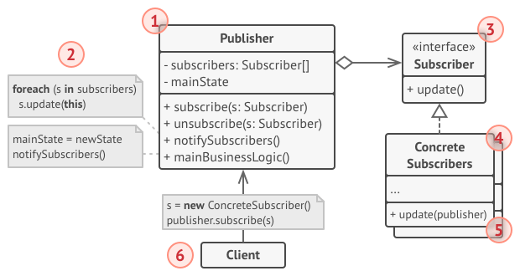

1. The **Publisher** issues events of interest to other objects. These events occur when the publisher changes its state or executes some behaviors. Publishers contain a subscription infrastructure that lets new subscribers join and current subscribers leave the list.
2. When a new event happens, the publisher goes over the subscription list and calls the notification method declared in the subscriber interface on each subscriber object.
3. The **Subscriber** interface declares the notification interface. In most cases, it consists of a single update method. The method may have several parameters that let the publisher pass some event details along with the update.
4. **Concrete Subscribers** perform some actions in response to notifications issued by the publisher. All of these classes must implement the same interface so the publisher isn’t coupled to concrete classes.
5. Usually, subscribers need some contextual information to handle the update correctly. For this reason, publishers often pass some context data as arguments of the notification method. The publisher can pass itself as an argument, letting subscriber fetch any required data directly.
6. The **Client** creates publisher and subscriber objects separately and then registers subscribers for publisher updates.

## Pseudocode

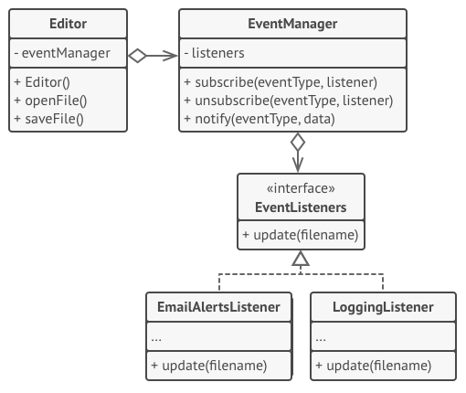

# State

## Intent

**State** is a behavioral design pattern that lets an object alter its behavior when its internal state changes. It appears as if the object changed its class.

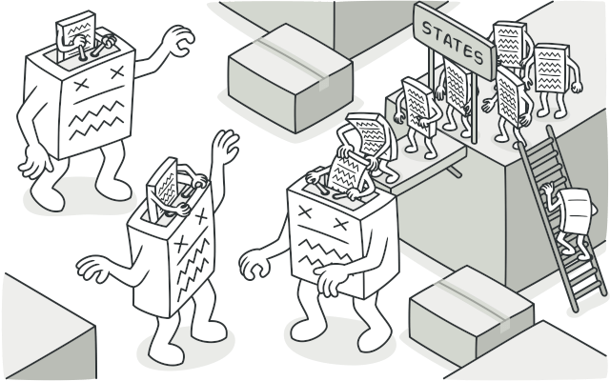

## Real-world analogy

The buttons and switches in your smartphone behave differently depending on the current state of the device:

* When the phone is unlocked, pressing buttons leads to executing various functions.
* When the phone is locked, pressing any button leads to the unlock screen.
* When the phone’s charge is low, pressing any button shows the charging screen.

## Structure

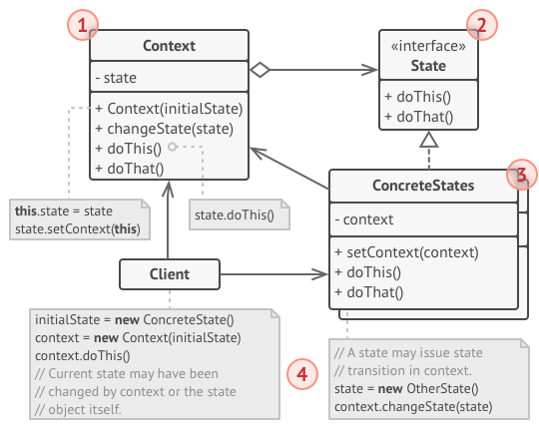

1. **Context** stores a reference to one of the concrete state objects and delegates to it all state-specific work. The context communicates with the state object via the state interface. The context exposes a setter for passing it a new state object.
2. The **State** interface declares the state-specific methods. These methods should make sense for all concrete states because you don’t want some of your states to have useless methods that will never be called.
3. **Concrete States** provide their own implementations for the state-specific methods. To avoid duplication of similar code across multiple states, you may provide intermediate abstract classes that encapsulate some common behavior.

State objects may store a backreference to the context object. Through this reference, the state can fetch any required info from the context object, as well as initiate state transitions.

1. Both context and concrete states can set the next state of the context and perform the actual state transition by replacing the state object linked to the context.

## Pseudocode

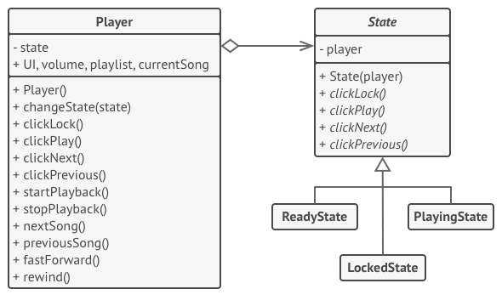

# Strategy

## Intent

**Strategy** is a behavioral design pattern that lets you define a family of algorithms, put each of them into a separate class, and make their objects interchangeable.



## Real-world analogy

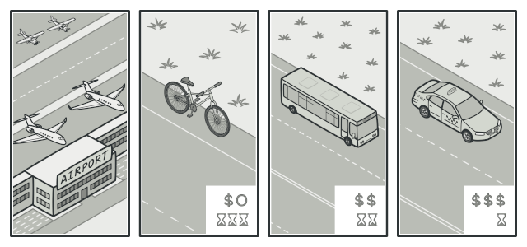

Imagine that you have to get to the airport. You can catch a bus, order a cab, or get on your bicycle. These are your transportation strategies. You can pick one of the strategies depending on factors such as budget or time constraints.

## Structure

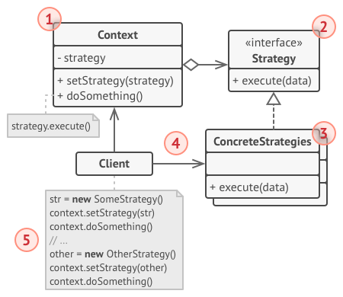

1. The **Context** maintains a reference to one of the concrete strategies and communicates with this object only via the strategy interface.
2. The **Strategy** interface is common to all concrete strategies. It declares a method the context uses to execute a strategy.
3. **Concrete Strategies** implement different variations of an algorithm the context uses.
4. The context calls the execution method on the linked strategy object each time it needs to run the algorithm. The context doesn’t know what type of strategy it works with or how the algorithm is executed.
5. The **Client** creates a specific strategy object and passes it to the context. The context exposes a setter which lets clients replace the strategy associated with the context at runtime.

# Template Method

## Intent

**Template Method** is a behavioral design pattern that defines the skeleton of an algorithm in the superclass but lets subclasses override specific steps of the algorithm without changing its structure.

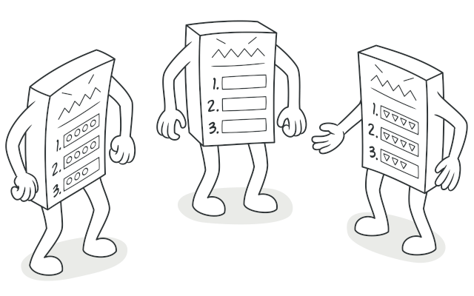

## Real-world analogy

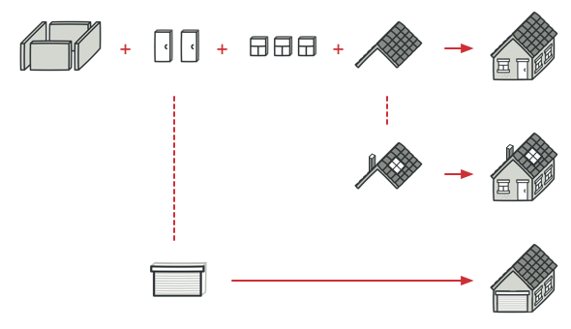

The template method approach can be used in mass housing construction. The architectural plan for building a standard house may contain several extension points that would let a potential owner adjust some details of the resulting house.

Each building step, such as laying the foundation, framing, building walls, installing plumbing and wiring for water and electricity, etc., can be slightly changed to make the resulting house a little bit different from others.

## Structure

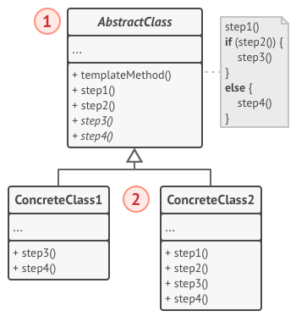

1. The **Abstract Class** declares methods that act as steps of an algorithm, as well as the actual template method which calls these methods in a specific order. The steps may either be declared abstract or have some default implementation.
2. **Concrete Classes** can override all of the steps, but not the template method itself.

## Pseudocode

